**In and out of a cell**

The drawing shows an animal cell.

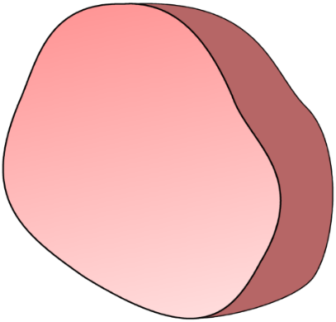

cell membrane

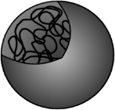

nucleus





mitochondria

Molecules of **oxygen** move into the cell through the cell membrane.

1. Which process moves oxygen molecules through the cell membrane?

|  |  |
| --- | --- |
| **A** | Breathing |
| **B** | Respiration |
| **C** | Diffusion |
| **D** | Concentration |

1. Why do oxygen molecules move into the cell?

|  |  |
| --- | --- |
| **A** | They move randomly in all directions. |
| **B** | They move in because the cell needs them. |
| **C** | They move in to keep the cell alive. |

**In and out of a cell**

The drawing shows an animal cell.



cell membrane



nucleus





mitochondria

Molecules of **carbon dioxide** move through the cell membrane.

1. Which statement is true?

|  |  |
| --- | --- |
| **A** | Carbon dioxide molecules only move **out** of an animal cell. |
| **B** | Carbon dioxide molecules only move **into** an animal cell. |
| **C** | Carbon dioxide molecules can move **both** into and out of an animal cell. |

1. How would you explain your answer to question 3?

|  |  |
| --- | --- |
| **A** | Carbon dioxide molecules can diffuse through the membrane in both directions. |
| **B** | The cell membrane is selectively permeable. |
| **C** | Carbon dioxide molecules are a waste product. |
| **D** | An animal cell does not need carbon dioxide molecules. |

*Biology > Big idea BCL: The cellular basis of life > Topic BCL1: Cells > Key concept BCL1.4: Diffusion and the cell membrane*

|  |
| --- |
| **Diagnostic question** |
| **In and out of a cell** |

**Overview**

|  |  |
| --- | --- |
| Learning focus: | Molecules move through the cell cytoplasm by diffusion, and some molecules can enter and leave a cell by diffusing through the cell membrane. |
| Observable learning outcome: | Explain the diffusion of particles through a selectively permeable membrane. |
| Question type: | Two-tier multiple choice |
| Key words: | membrane, selectively permeable, diffusion |

**What does the research say?**

Dreyfus and Jungwirth (1988) found that many 16-year-olds thought that cells contain macroscopic organs such as a digestive tract or lungs; this could be related to the misunderstanding that substances such as oxygen and food/glucose are taken into cells by breathing or eating, respectively, rather than by diffusion through the cell membrane (Allen, 2014). Incorrect animistic and anthropomorphic views were also commonly observed in students, including the belief that cells and organelles have desires and intentions (e.g. they ‘know’ or ‘want’ to take in and discard particular substances).

**Ways to use this question**

Students should complete the questions individually. This could be a pencil and paper exercise, or you could use the PowerPoint presentation with an electronic voting system or mini white boards.

The answers will show you whether students understand the diffusion of molecules across a selectively permeable cell membrane, and whether they have misunderstandings such as animistic and anthropomorphic views of cells and molecules.

*Differentiation*

You may choose to read the questions to the class, so that everyone can focus on the science. In some situations it may be more appropriate for a teaching assistant to read for one or two students.

**Expected answers**

1. C – Diffusion
2. A – They move randomly in all directions.
3. C – Carbon dioxide molecules can move both into and out of an animal cell.
4. A – Carbon dioxide molecules can diffuse through the membrane in both directions.

Some answers may seem counterintuitive to students, for example that a waste product such as carbon dioxide can diffuse *into* a cell through the cell membrane (rather than just being moved out). In order to get the correct combinations of answers, students must be secure in their understanding of diffusion as a passive process that results from the random movement of molecules.

**How to respond - what next?**

If there is a range of answers, you may choose to respond through structured class discussion. Ask one student to explain why they gave the answer they did; ask another student to explain why they agree with them; ask another to explain why they disagree, and so on. This sort of discussion gives students the opportunity to explore their thinking and for you to really understand their learning needs. Responses often work best when the activities involve paired or small group discussions, which encourage social construction of new ideas through dialogue.

Researchers have described constructivist approaches that enable students to build their own explanations of diffusion, which may help to develop students’ understanding and overcome misconceptions, including use group discussion and challenging students to apply concepts they have been taught to make predictions (Christianson and Fisher, 1999). The following BEST ‘response activity’ facilitates these types of activities and reinforce the idea that diffusion does take place across non-living membranes and does not rely on the actions, needs or wants of a cell. It could therefore be used in follow-up to this diagnostic question:

* Response activity: PEOE – A cup of tea

**Acknowledgments**

Developed by Alistair Moore (UYSEG).

Images: cell outline – UYSEG; mitochondria – pixabay.com/argzombies (3016868); nucleus – UYSEG

**References**

Allen, M. (2014). *Misconceptions in Primary Science, Second* ednBerkshire, UK: Open University Press.

Christianson, R. G. and Fisher, K. M. (1999). Comparison of student learning about diffusion and osmosis in constructivist and traditional classrooms. *International Journal of Science Education,* 21(6)**,** 687-698.

Dreyfus, A. and Jungwirth, E. (1988). The cell concept of 10th graders: curricular expectations and reality. *International Journal of Science Education,* 10(2)**,** 221-229.